# Basic Electrical Science Lab

**Course Code: EE152**

**Laboratory Manual**

## Name:

Roll No.:

Section:

Academic Session: April – August 2021

**National Institute of Technology Goa**



**C ERTIFICATE**

### This is to certify that Mr./ Ms. of

Class

.Tech 1s t year (2n d Sem), Division Sec A/B, bearing Roll.

No. , has satisfactorily completed the course experiments in the Laboratory Course Basic Electrical Science L ab (EE152) in the academic year 2020-2021 in the Institution of National Institute of Technology Goa.

**Course Instructor**

**T able of Contents**

|  |  |  |  |  |  |
| --- | --- | --- | --- | --- | --- |
| **Sl. No.** | **Name of the Experiment** | **Pg. No.** | **Date of**  **Experiment** | **Date of Submission** | **Marks/Expt**  **.**  **(10 M)** |
| **1** | **Verification of Ohms Law** | **04** | **20-05-2021** |  |  |
| **2** | **Verification of Kirchhoff's Laws – KVL and KCL** | **07** |  |  |  |
| **3** | **Verification of Thevenin’s and**  **Norton’s Theorem** |  |  |  |  |
| **4** | **Measurement of AC System quantities – Average, RMS, Form**  **Factor, Peak Factor, P, Q, pf** |  |  |  |  |
| **5** | **Measurement of Self, Mutual and Coefficient of Coupling** |  |  |  |  |
| **6** | **V-I Characteristics of P- N Junction and Zener Diode** |  |  |  |  |
| **7** | **Half-wave Diode Rectifier** |  |  |  |  |
| **8** | **Full-wave Diode Rectifier** |  |  |  |  |
| **9** | **Transient analysis of RL, RC and RLC Circuits** |  |  |  |  |
| **10** | **Digital Gate Circuits** |  |  |  |  |

**Experiment 1**

**Verification of Ohms Law**

1. **Aim**: To verify Ohms Law for the given circuit
2. **Software tools required:** MATLAB/SIMULINK
3. **Simulink Block sets Used:** Powergui, DC Voltage Source, Series RLC Branch, Current Measurement, Voltage Measurement, Display, Scope, XY Graph, Controlled Voltage Source, Ramp
4. **Theory**: Ohms Law states that the voltage across conducting materials is directly proportional to the current through the material. one arrives at the usual mathematical equation that describes this relationship

V α I

⇨ V = IR

Where, V – Voltage across the element

I – Current flowing through the element R - Resistance offered by the element

R is also the slope of the straight line when V-I characteristics are plotted. Normally resistance is a positive quantity.

1. **Circuit Diagram:** The considered circuit for Ohms law verification is as given in fig. 1a. The connected circuit in MATLAB/Simulink is given in Fig.1b.

#### (0-100 V)

100 V



**V**

(0-5 A)

**A**

20 Ω

**Fig1a**: Circuit Diagram

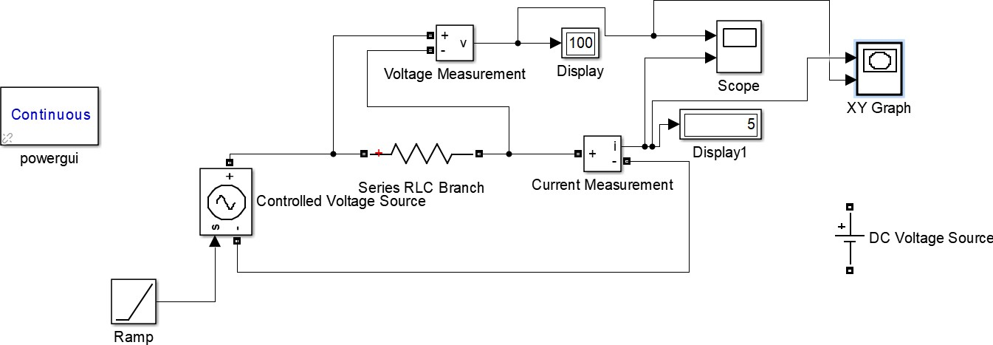

##### Procedure:

**Fig1b**: Circuit connections in Simulink

* 1. The mentioned Simulink blocksets are connected as shown in Figure 1b.
  2. Apply the specified voltage across the specified resistance
  3. Measure the current flowing through the resistor
  4. V-t, I-t and V-I plots are generated
  5. The same procedure is repeated for specified types of inputs like Constant DC, Ramp, etc.

##### Graphical Results:

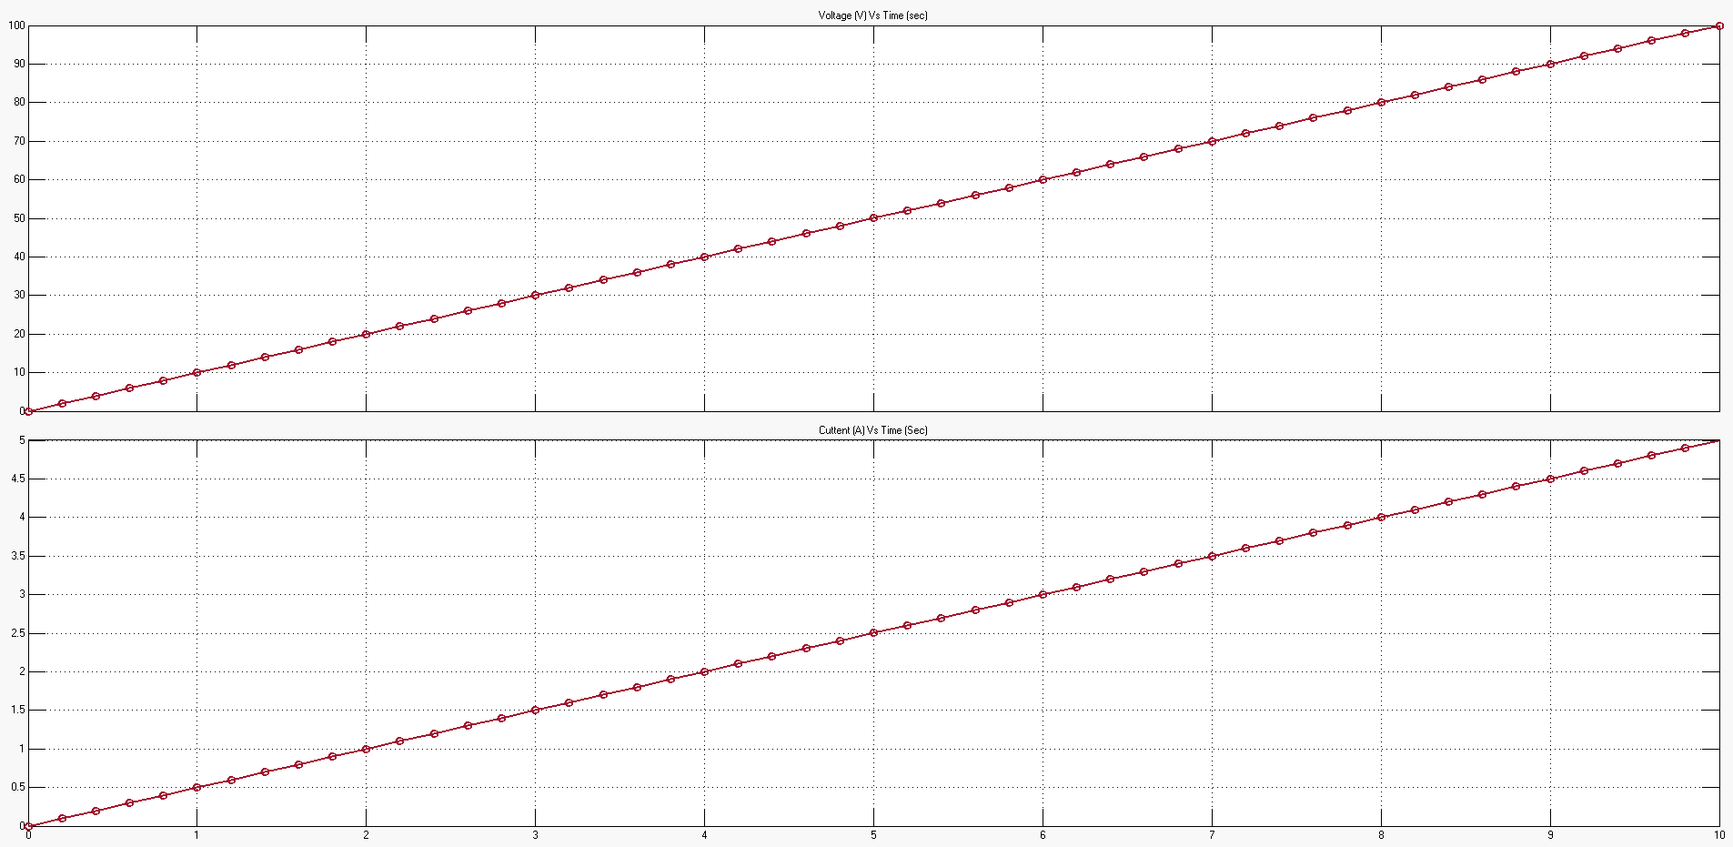

**Fig.2a:** Voltage Vs Time and Current Vs time Plots